Directions for managing your own Grace Kelly Studio account on Studio Director (our online management system):
- Click here to go to the Studio Director (SD) website.
- Because you are already in our system, you actually are “Already Registered with GKS.” Please select “Forgot your password?” and follow the standard procedures for password recovery (email, link back to site, creating a new password). Please do not try to register as “New to GKS” because it will generate a new accouont and that will not be associated with your dancer.

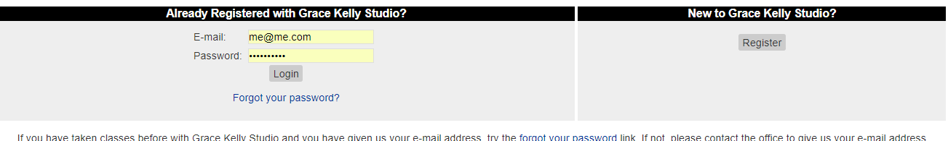

- Once you are in Studio Director, choose “Pay Now” in order to set up an online payment with your credit card. Please note that this applies to families who are either paying monthly or annually, and it does not require you to set up an automatic payment account; you may log on monthly and pay your tuition.
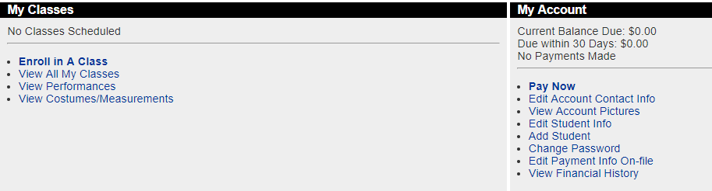
- By default, you need to pay your balance, so press next. You may enter a greater amount if you choose to pre-pay. If you are going to set up “Auto-Pay,” you will do so in Step 2 of 3.
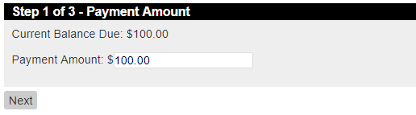

- Choose “Enter a New Payment Method” and press “Next.” Remember, you will have the option to pay your monthly tuition by check or cash in future months if you choose.
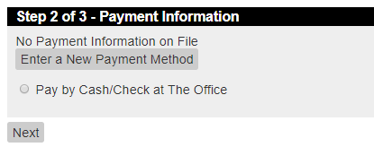

- The program auto-fills most of your information with the exception of your first name. Fill that in. This is the step where you may choose to enroll in auto-pay. Should you choose this option, you will be charged on the 11th of each month. It is your responsibilty to update your credit card information. If your card is declined, you will receive an email to that effect and can update your information accordingly.

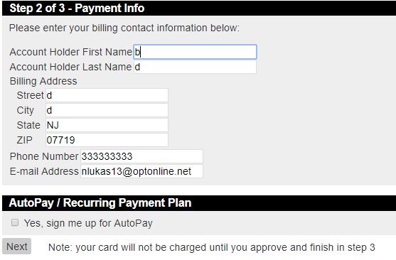

- Enter your credit card information. And click “OK.”
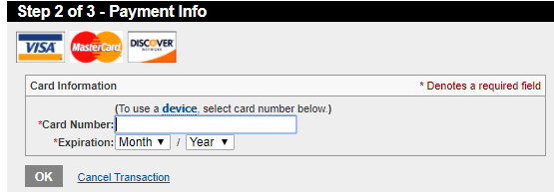

- In this step, you merely confirm the information from the previous screen. Click “Next.”
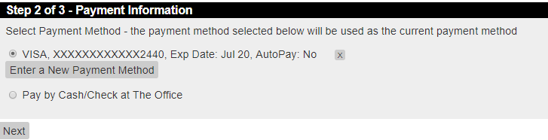
- Please read the agreement, check the box, and hit “Accept.”
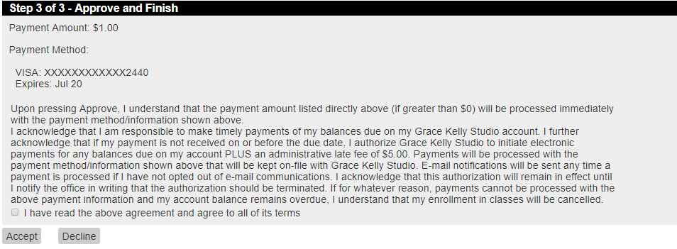
- You will receive an email notification to confirm your payment.

